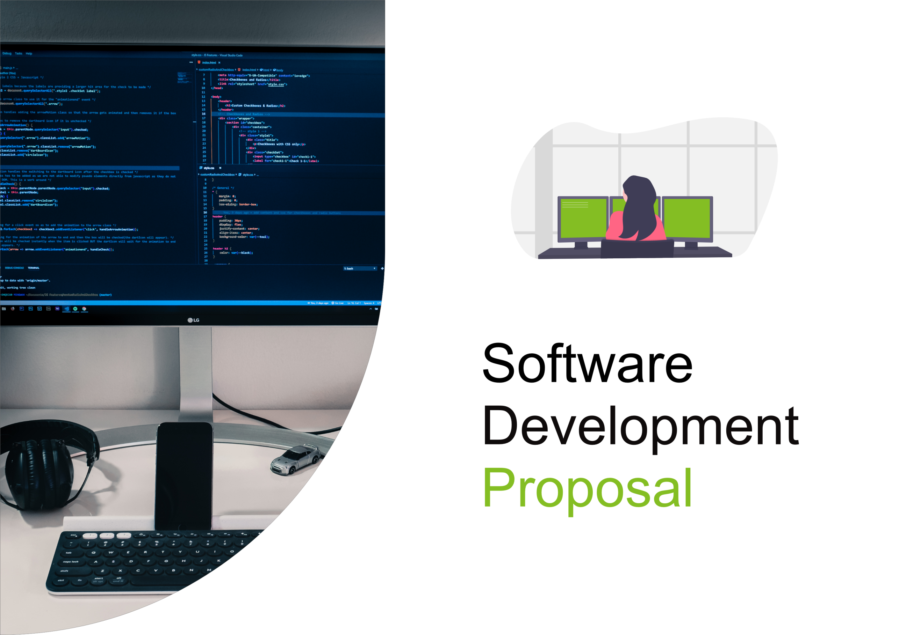

1. Overview

This proposal outlines the development of a private dashboard for Daikibo to monitor the health status of their machines across four factories. The dashboard will be accessible within the company's intranet and leverage existing internal authentication for user convenience.

2. Scope

The project will deliver a single-page web application with the following functionalities:

* **Real-time Status:** Display the current health status of all nine machines in each of Daikibo's four factories.
* **Collapsible/Expandable View:** Allow users to collapse and expand the view by factory or individual device.
* **Detailed History:** Provide access to historical status data for each device upon expanding the view.
* **Internal Authentication:** Integrate with Daikibo's existing authentication system for seamless user access.
* **Intranet Access:** Ensure the dashboard is accessible only within the secure company intranet network.

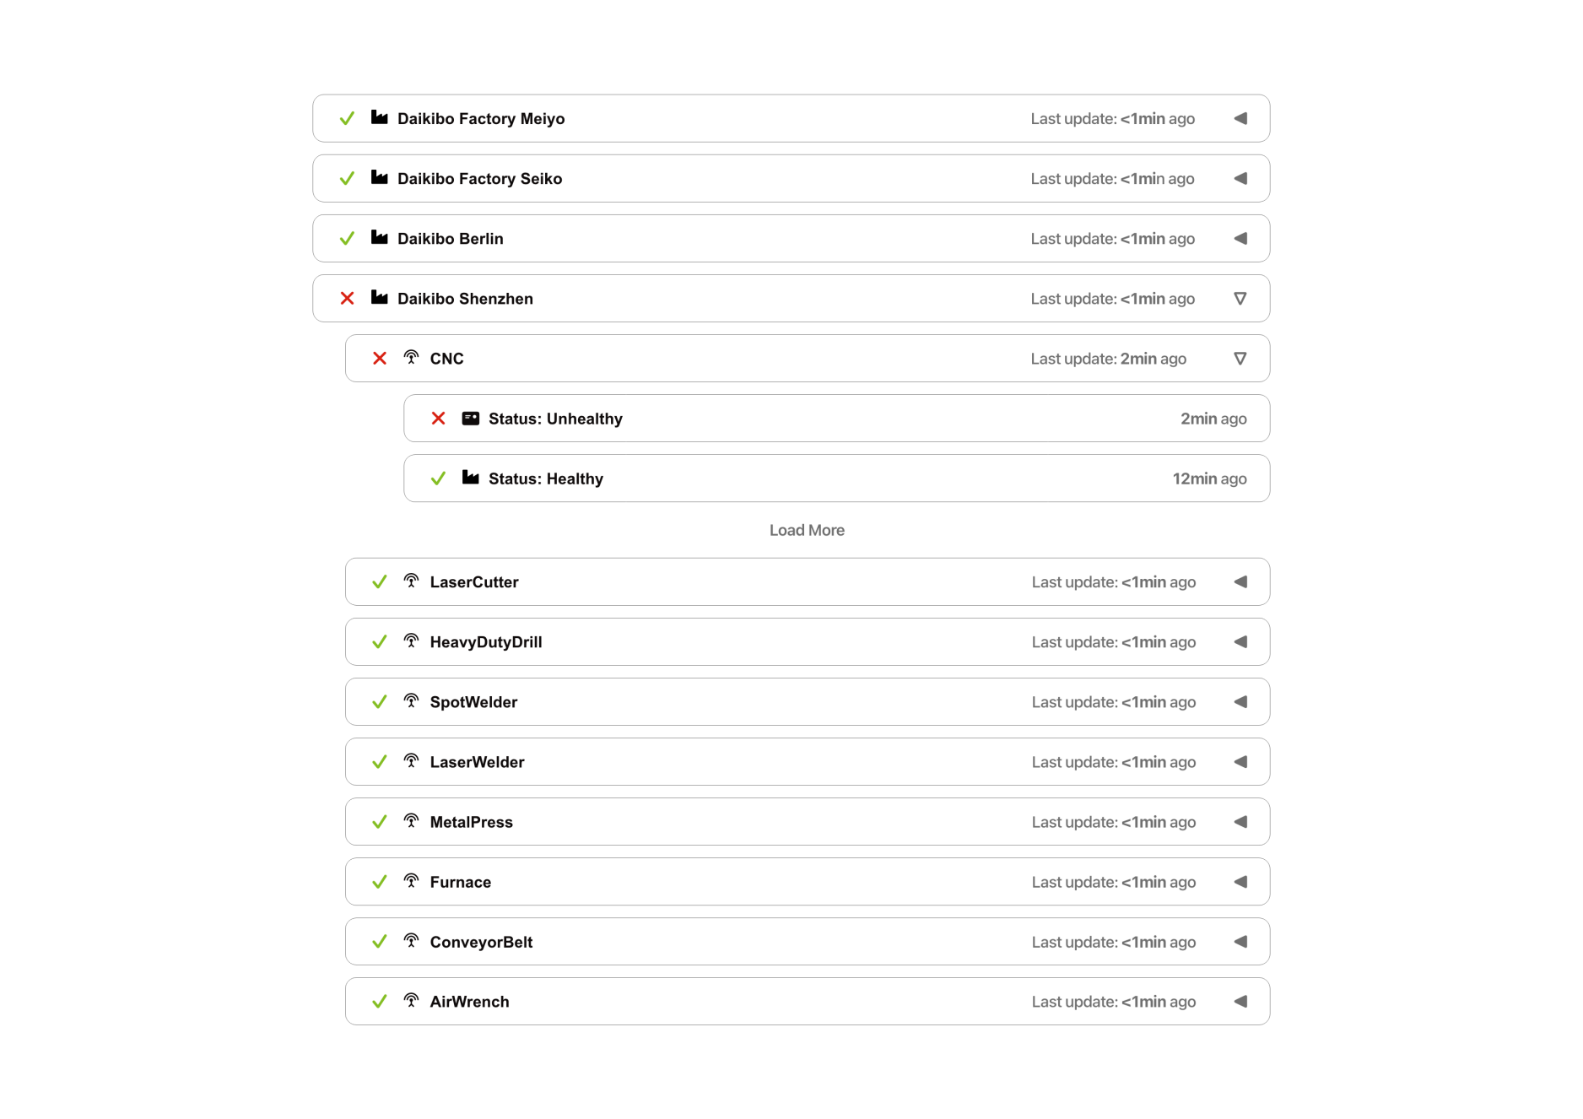

3. Estimate

The development process is estimated to require the following approximate man-hours:

Development: 80 hours

Testing: 40 hours

Integration: 20 hours

Total Estimated Effort: 140 man-hours

4. Timeline

The project timeline will be further refined upon contract approval, but a high-level breakdown is as follows:

1. Week 1: Project kickoff, requirements gathering, and system design.
2. Weeks 2-5: Development of core functionalities.
3. Weeks 6-7: Integration testing and bug fixing.
4. Week 8: User Acceptance Testing (UAT) and final adjustments.
5. Week 9: Deployment and user training.

5. Support

We understand We understand the importance of ongoing support for your applications. We offer a comprehensive support package that includes:

* Bug fixes and technical support for reported issues.
* Assistance with user inquiries and troubleshooting.
* Ongoing maintenance and updates to ensure compatibility with evolving technologies.